**EN3160 – Image Processing and Machine Vision**

**Assignment 02 – Fitting and Alignment**

**H.M.R.M. Pushpakumara – 200488E**

**Question 01**

Here we have to detect blobs by using Gaussian and scale-space extrema detection.

I used sigma = 1 and sigma = 2 as my sigma values and my threshold value is 0.35.

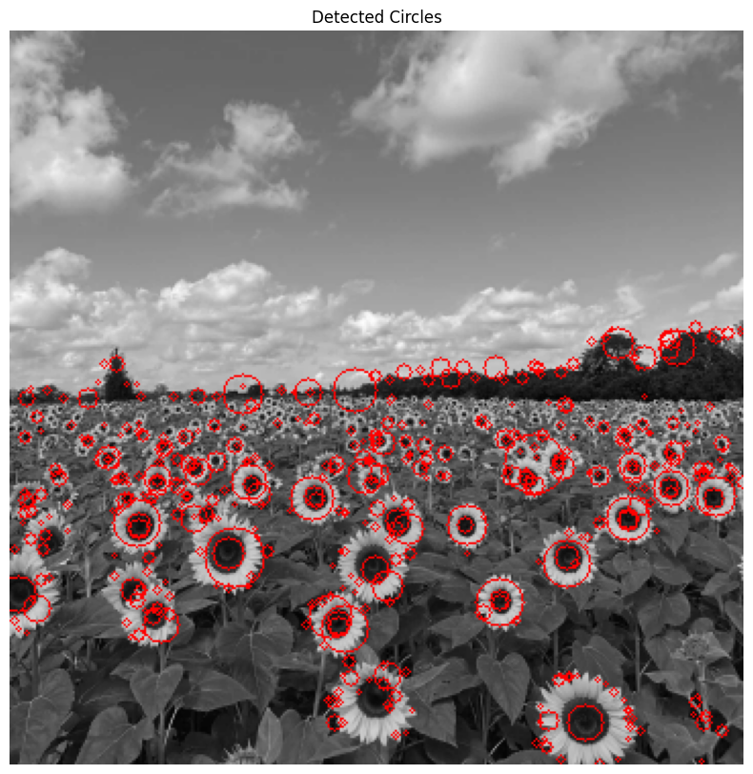

Parameters of the largest circle:

* Center: (110, 258)
* Radius: 20
* Sigma value: 2

**Question 02**

**(a)**

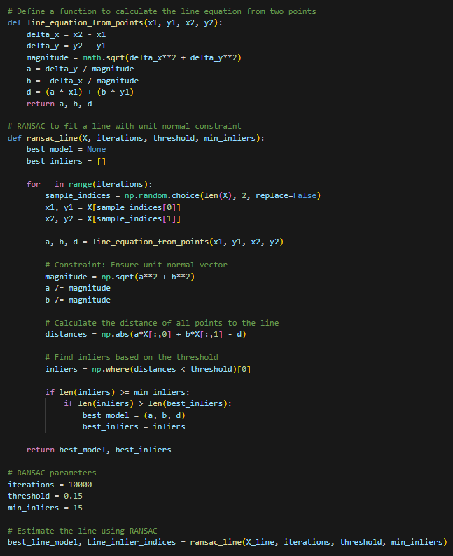

Number of inliers in this model: 16

Parameters of the estimated line:

* a: 0.7080986693010423
* b: 0.7061134997534697
* d: 1.5303717301982513

**(b)**

Number of remnant points: 84

Number of inliers in the circle: 16

Parameters of the estimated circle:

* x_center: 2.0388812056906938
* y_center: 2.905374551155992
* radius: 9.971739443086292

**(c)**

**Question 03**

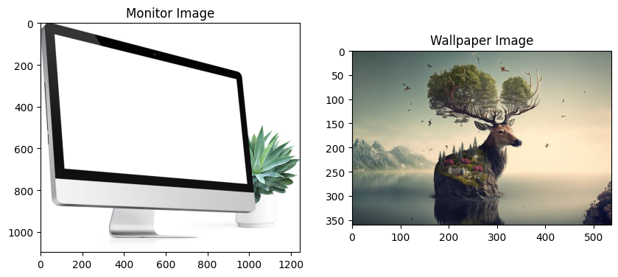

I chose a desktop image and an HD image to do this. My task was to add this HD image to the desktop as its wallpaper.

To define the 4 points on the desktop image, I generate a pixel grid on the image and by looking at that grid, I defined my four points.

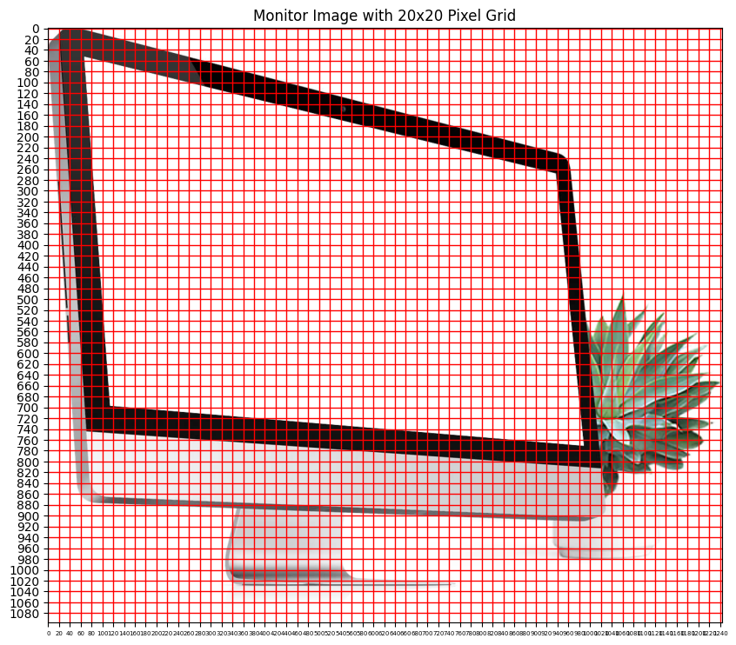

This image also generated by me by using the same approach.

**Question 04**

Image1 and Image5

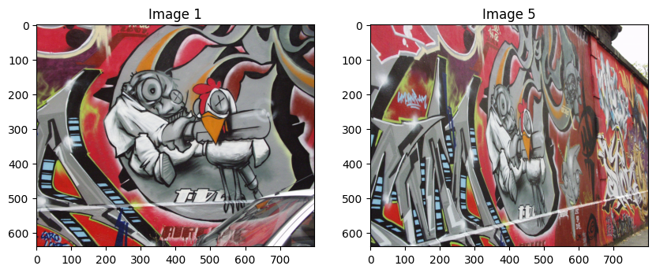

When we use a brute-force matcher, it gives lots of crossmatches between two images. From that, we can’t perform good image stitching.

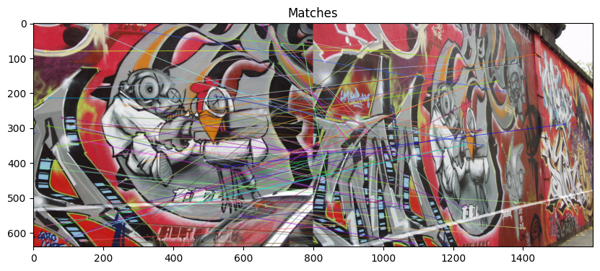

Therefore, I implemented a RANSAC matching function for this.

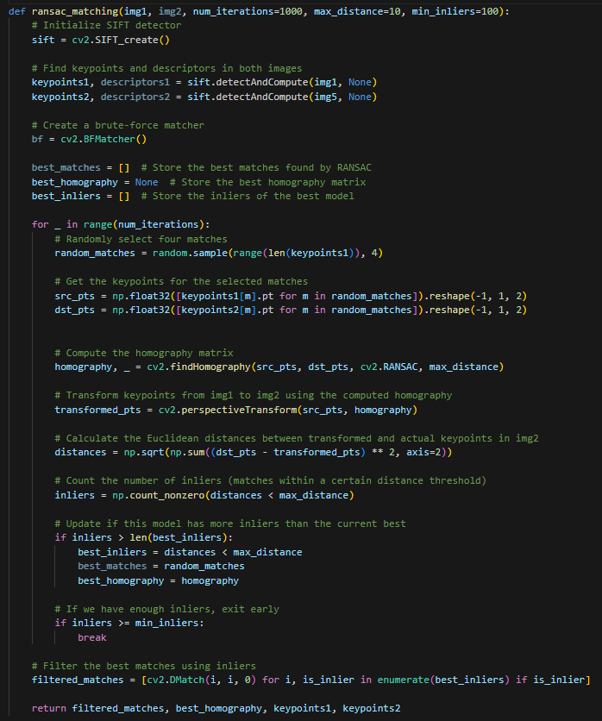

By using this, I generated a homography matrix.

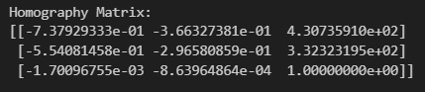

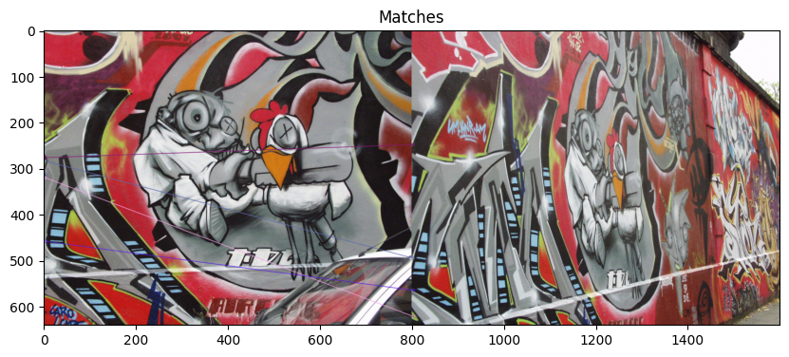

But this also not worked properly. I had non-cross exact matches, but only on the edge of the images.

Therefore, I used the given homography matrix for image1 to image5.

Then I got this final image.

<https://github.com/RavinduMPK/EN3160---Image-Processing-and-Machine-Vision>

Direct to the assignment:

<https://github.com/RavinduMPK/EN3160---Image-Processing-and-Machine-Vision/tree/main/Assignment_02%20%20-%20Fitting%20and%20Alignment>